Stability filtered lattice matching for the discovery of supercooling nucleants in gallium and its low melting alloys
Michael E. Bustamante, Gabriel Bustamante
OdinZen LLC, Houston, TX, USA
Corresponding author: michaelbusta@odinzen.io | ORCID 0009-0009-9001-8151

Abstract
Gallium and its low melting alloys carry a high latent heat and melt near room temperature, yet they supercool by tens of kelvin before they freeze, which makes solidification unreliable and limits their use as phase change media. The remedy is a heterogeneous nucleant, and the usual way to choose one is to match its lattice to the freezing solid. We argue that a lattice match alone is not enough in gallium, because the metal is strongly oxophilic and reduces many candidate oxides before they can act, so we add a second criterion, chemical stability in the melt, and weigh the two together through the Odinzen engine. With the literature interfacial energy of 56 mJ per square metre, classical heterogeneous nucleation reproduces the measured homogeneous supercooling of pure gallium, 66.9 K against 67.8 K, and recovers the measured endpoints of the five nucleant ranking of Zhang and co workers, with TeO2 at the head. A thermodynamic gate then shows that gallium reduces TeO2 to Ga2O3 and tellurium; all three phases are near coherent to alpha-Ga, which is why TeO2 works even as it is consumed. Screening thirty seven oxides, carbides, nitrides, and borides on verified crystallography and formation energies isolates a stable, near coherent family of refractory ceramics, led by HfN and ScN at better than half a percent and followed by VO2, NbC, ZrN, TaC, and TiO2. A transient cell model converts the residual supercooling into device protection time and sets a design rule, that the nucleant must cut the residual below the thermal margin between the melt point and the cold plate. Two members of this family are already measured, since ZrN and HfC cut gallium supercooling below 10 and 20 K, and that anchors the prediction that the near coherent members HfN and ScN, as yet untested, should act as strong single phase agents.
Keywords: gallium; supercooling; heterogeneous nucleation; nucleating agent; phase change material; lattice matching

Nomenclature
Symbol | Definition and unit
dG_v | Volumetric free energy driving force, J/m^3
dG* | Nucleation barrier, homogeneous or heterogeneous, J
dH_f | Molar latent heat of fusion, J/mol
V_m | Molar volume of the solid, m^3/mol
dT | Undercooling, T_liq minus T, K
T_liq, T_m | Liquidus and melt temperature, K
T_s | Cold plate set point, K
gamma | Solid liquid interfacial energy, J/m^2
theta | Wetting contact angle of solid on substrate, degrees
f(theta) | Spherical cap potency factor, dimensionless, 0 to 1
I, I0 | Steady state nucleation rate and its prefactor, per m^3 per s
k_B | Boltzmann constant, 1.380649e-23 J/K
delta | Planar lattice disregistry to the alpha-Ga (010) face, percent
Undercoolings are temperature intervals, so one kelvin equals one degree Celsius as an interval; values quoted from the cited experiments appear as those authors reported them.

1. Introduction
Gallium melts near room temperature and carries a high volumetric latent heat, and when it is alloyed with indium and tin it stays liquid across a wide window. Those properties make gallium and the eutectic alloy Ga-In-Sn appealing as phase change media for compact thermal management, as thermal interface materials, and as soft conductors. One behaviour undercuts the promise. On cooling, gallium does not freeze at its equilibrium point; it supercools by tens of kelvin before it nucleates, and the onset is erratic. Pure gallium supercools by close to 68 C in bulk, and the freezing point of the eutectic alloy scatters across tens of degrees, so any device that depends on a clean melt freeze cycle is left without a dependable set point.
Supercooling is a nucleation problem. A melt held below its liquidus stays liquid because the first solid embryo must pay an interfacial energy cost that the volumetric driving force has not yet returned. A foreign particle that the solid wets lowers that cost and lets nucleation begin at a small undercooling, and the potency of the particle is set by how well its surface matches the crystal plane of the forming solid. Telkes captured this with a working rule, that an effective agent differs from the host by less than fifteen percent in the relevant spacing, and Bramfitt placed the planar disregistry on a quantitative footing. Work on gallium has followed that logic along two lines. Zhang and co workers screened TeO2, CaO, MgO, iron, and copper, ranked them by lattice similarity to alpha-Ga, and measured the largest reduction of supercooling for TeO2. Separately, a set of lattice matched cubic carbides and nitrides was shown to nucleate gallium, with ZrN and HfC bringing the undercooling below 10 and 20 C from a baseline above 60 C.
The oxide line of that reasoning leaves out a step. Gallium is strongly oxophilic, and several oxides that match its lattice are not inert in the melt; the metal can reduce them before they nucleate anything. The native gallium oxide skin is the cautionary case, a poor nucleant that tends to deepen supercooling rather than relieve it. We therefore weigh chemical stability alongside crystallography, test the combined criterion against both the oxide and the carbide nitride measurements, and use it to screen a broad library for the strongest agents.

2. Methods

2.1 Heterogeneous nucleation model
Solidification onset is treated with classical nucleation theory. Near the liquidus the volumetric driving force takes the Turnbull form, dG_v = (dH_f / V_m)(dT / T_liq), where dH_f is the molar latent heat of fusion, V_m the molar volume of the solid, and dT the undercooling. The barrier to a homogeneous nucleus is 16 pi gamma^3 / (3 dG_v^2), with gamma the solid liquid interfacial energy, and a foreign substrate scales that barrier by the spherical cap potency f(theta) = (2 - 3 cos theta + cos^3 theta) / 4, which runs from zero for a perfectly wetting, lattice matched substrate to one for a substrate the solid ignores. We report the activated undercooling, the value of dT at which the steady state nucleation rate first reaches a detectable threshold. The model runs as a substrate generic capability in the Odinzen engine.

2.2 Lattice disregistry and potency
When no measured contact angle is available, the potency follows from the lattice match between the substrate and the plane on which gallium nucleates. Chakravarty and co workers identify that plane as the (010) face of alpha-Ga, a near square of edge 4.523 Angstrom. We therefore take the disregistry as the mismatch between that face and the substrate near square face, the quantity abs(x - 4.523) / 4.523 over the substrate lattice parameters, and map it to f(theta) by a bounded relation after Turnbull and Vonnegut. A substrate has to present a face of the right edge for the match to count; a single axis that happens to equal the gallium c axis of 7.66 Angstrom is a one dimensional coincidence, not a planar match, and is excluded. That restriction is what lets the screen reproduce the measured ranking.

2.3 Chemical stability in the melt
The fate of a candidate in the melt is decided by its class. An oxide resists reduction only when its Gibbs energy of formation per mole of O2 lies below that of Ga2O3, minus 665 kJ per mole of O2; above that line gallium strips the oxygen to make Ga2O3 and frees the cation, as in 3 TeO2 + 4 Ga giving 2 Ga2O3 + 3 Te, a reaction worth about minus 1184 kJ across the melt window. Refractory carbides, nitrides, and borides are taken as inert, because gallium forms no stable carbide, nitride, or boride at these temperatures; the same inertness is why such ceramics serve as crucibles for liquid gallium.

2.4 Data
The liquidus and latent heat of Ga-In-Sn come from a CALPHAD database solved with the open source pycalphad package. Lattice parameters and standard formation energies are verified values drawn from the Inorganic Crystal Structure Database, the Materials Project, and the NIST-JANAF and CRC compilations. For the gallium solid liquid interfacial energy we use the nucleation literature value of 56 mJ per square metre, which the model also recovers on its own from the measured homogeneous supercooling. The engine ties together the database query, the nucleation calculation, and the stability gate.

3. Results and discussion

3.1 Baseline supercooling and interfacial energy
With that interfacial energy and the latent heat of gallium, the model puts the homogeneous supercooling of pure gallium at 66.9 K, against 67.8 plus or minus 1.1 K measured by Zhang and co workers for gallium with no nucleant. The two agree to about a degree, and because the same interfacial energy is the one those authors adopt, the baseline is tied to the measurement on both the input and the output side.

3.2 Validation against the measured oxide ranking
Two independent experiments fix the metric. Figure 1 plots the measured undercooling of gallium against the (010) disregistry for every nucleant reported by Zhang and co workers and by Chakravarty and co workers. The undercooling falls smoothly as the disregistry shrinks and saturates above about five percent, the threshold the second study identifies. Table 1 lists the Zhang set: TeO2 and CaO, both near six percent, give the deepest reductions, while copper and iron, far from the (010) match, give only modest reductions that lattice registry does not explain. Across the seven cubic carbides and nitrides, the controlled single class test, the predicted order matches the measured one with a Spearman rank correlation of 0.96; across all twelve measured phases it holds at 0.72, both significant. A straight line understates the link because the undercooling saturates above about five percent, where a fit against the log of the disregistry is significant. Copper and iron sit off the trend because they nucleate gallium through a metallic path rather than by lattice registry, and the saturation is why no oxide alone drives gallium close to its liquidus.
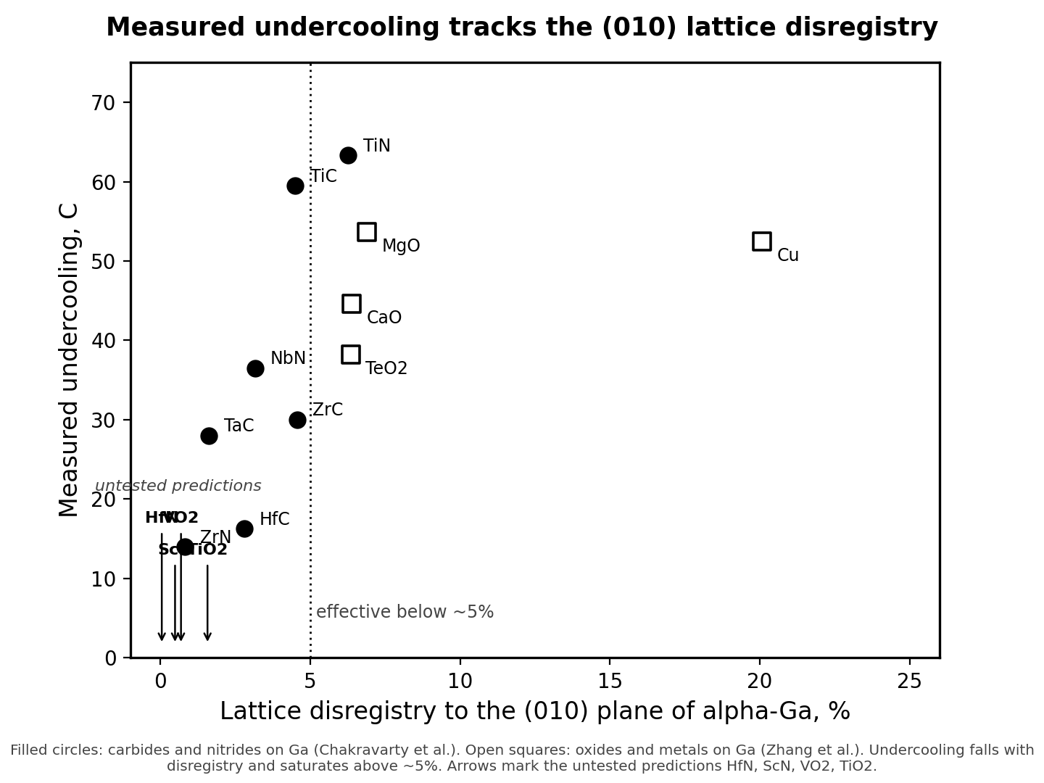
Fig. 1. Measured undercooling of gallium against the lattice disregistry to its (010) nucleation plane. Filled circles are carbides and nitrides on gallium (Chakravarty et al.); open squares are oxides and metals on gallium (Zhang et al.). Undercooling falls with disregistry and saturates above about five percent. Arrows mark the untested predictions HfN, ScN, VO2, and TiO2.
Table 1. Measured supercooling and predicted lattice disregistry for the five nucleants of Zhang and co workers.
Nucleant (loading) | Measured dT (C) | Reduction (%) | (010) disregistry (%) | Predicted f
none (pure Ga) | 67.8 +/- 1.1 | 0 | -- | 1.00
TeO2 (0.5 wt%) | 38.2 +/- 5.4 | 43.7 | 6.3 | 0.32
CaO (0.5 wt%) | 44.6 +/- 5.8 | 34.2 | 6.4 | 0.33
Cu | 52.5 +/- 2.6 | 22.6 | 20.1 | 1.00
MgO | 53.7 +/- 4.3 | 20.8 | 6.9 | 0.41
Fe | 53.8 +/- 3.4 | 20.6 | 36.6 | 1.00

3.3 The fate of TeO2 in the melt
The gate recasts what the best oxide actually is. On the Ellingham diagram Ga2O3 lies far below TeO2, by roughly 395 kJ per mole of O2 across the window, so the displacement runs strongly to the right and TeO2 is reduced to Ga2O3 and tellurium; what was dispersed as TeO2 does not persist as TeO2 in the bulk. The match TeO2 offers the (010) plane is only moderate, 6.3 percent through its a axis, which fits the moderate reduction it produces rather than a near coherent one. Its reduction products are comparable, with liberated tellurium matching a gallium repeat to about one and a half percent, so the reduced agent templates about as well as the parent. That moderate match is why TeO2 is the best oxide and still far from the carbide and nitride leaders.
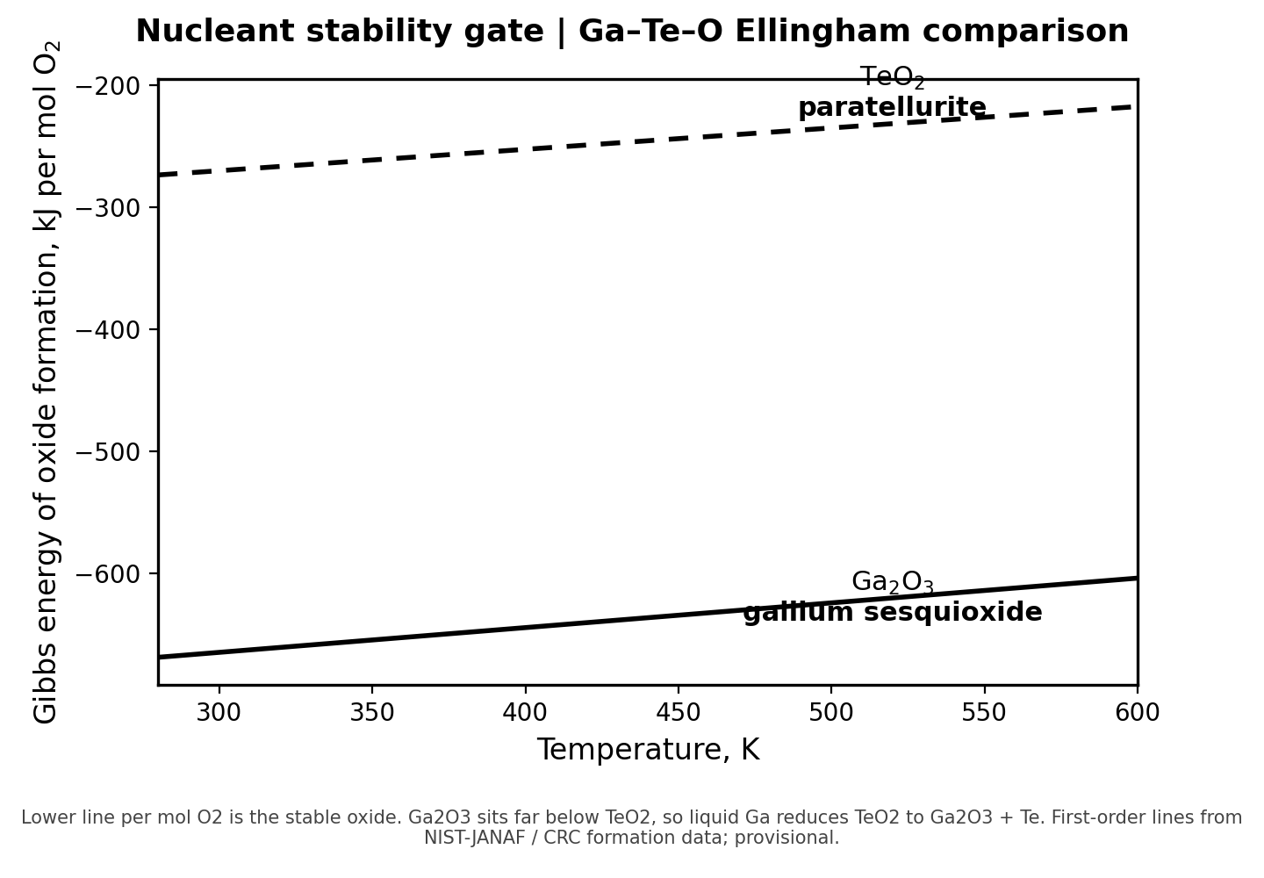
Fig. 2. Ellingham comparison of oxide formation per mole O2 for Ga2O3 and TeO2. Ga2O3 sits far below TeO2 across the melt window, so liquid gallium reduces TeO2 to Ga2O3 and tellurium.

3.4 A broad, stability filtered candidate screen
The two criteria pull against each other, and that is the point of the screen. Compounds spanning rutile type and related oxides, rocksalt carbides and nitrides, and AlB2 type borides were placed by their (010) disregistry and by their stability in the melt; Table 2 and Fig. 3 collect the survivors that match to better than three percent. A broad Materials Project query, restricted to experimentally observed phases, was screened the same way. It returned real compounds such as Ta2O5 and Nb2O5 at an apparent fraction of a percent, but each of those scores is a one dimensional coincidence between an axis and the gallium c axis, and the (010) criterion rejects them. The experimental marker for that failure mode is beta-Si3N4, which a single axis places near the gallium c axis yet which Chakravarty and co workers measured as a control that did not work. The compounds that pass both filters fall into two groups. The refractory carbides and nitrides are inert to gallium and several are near coherent on the (010) face: HfN matches to five hundredths of a percent through its cube edge, ScN to half a percent, and NbC, ZrN, and TaC to within one and a half. Among the oxides, VO2 and TiO2 resist reduction and match to within one and a half percent, so they remain workable single phase oxide agents.
The carbide and nitride branch is more than a prediction. Lattice matched cubic carbides and nitrides have already been measured on gallium, and ZrN and HfC, both among the survivors of Table 2, brought the undercooling below 10 and 20 C from a baseline above 60. That the screen places exactly these phases near the front, on the same matching logic, is independent support for the method. The prediction it then makes is narrow and testable: HfN and ScN, near coherent to alpha-Ga and far more stable than any gallium nitride, should act as strong single phase nucleants, and neither has been tried. Table 3 sets that prediction beside the supercooling reductions reported for gallium and its alloys across the literature.
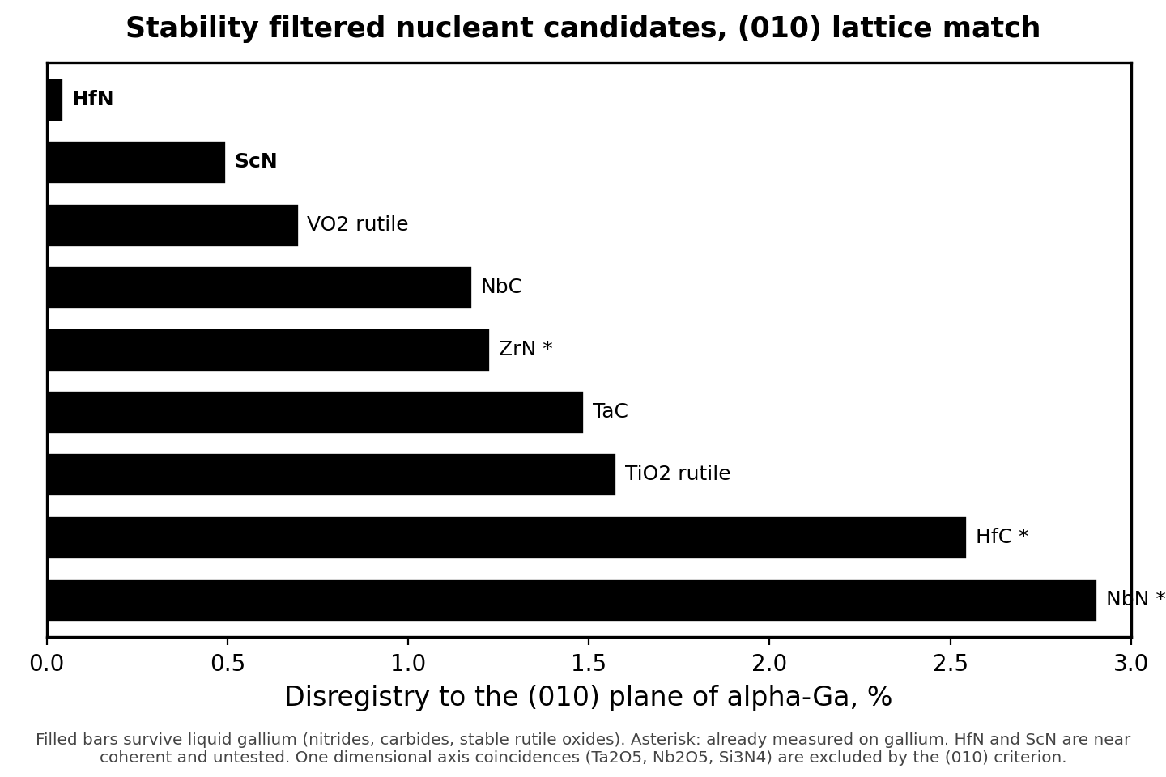
Fig. 3. Stability filtered candidates ranked by disregistry to the (010) plane of alpha-Ga. Filled bars survive liquid gallium; the asterisk marks a phase already measured on gallium. HfN and ScN are near coherent and untested; one dimensional axis coincidences such as Ta2O5 and beta-Si3N4 are excluded by the (010) criterion.
Table 2. Stability filtered candidates by (010) disregistry. The first eight survive liquid gallium; the last three are reduced oxides shown for comparison. Oxides are judged by the Ellingham criterion; carbides and nitrides are inert.
Compound | Class | (010) disregistry (%) | Fate in liquid Ga
HfN | nitride | 0.04 | survives (inert)
ScN | nitride | 0.49 | survives (inert)
VO2 (rutile) | oxide | 0.69 | survives
NbC | carbide | 1.17 | survives (inert)
ZrN | nitride | 1.22 | survives; measured <10 C
TaC | carbide | 1.48 | survives (inert)
TiO2 (rutile) | oxide | 1.57 | survives
HfC | carbide | 2.54 | survives; measured <20 C
IrO2 | oxide | 0.55 | reduced
RuO2 | oxide | 0.69 | reduced
TeO2 | oxide | 6.35 | reduced; measured 38 C

Table 3. Measured reduction of supercooling for gallium and Ga-In-Sn across the literature, including the carbide and nitride agents that the present screen also ranks at the top.
Nucleant | Host metal | Supercooling before to after | Source
ZrN | Ga | >60 to <10 C | [11]
HfC | Ga | >60 to <20 C | [11]
TeO2 (0.5 wt%) | Ga | 67.8 to 38.2 C | [1]
porous Cu / CuGa2 | Ga | 28.2 to 11.5 C | [12]
Cu particles | Ga-In-Sn | 80 to 36 K | [13]
graphene coating | Ga | 21.8 to 17.1 C | [12]

3.5 Application to the eutectic alloy Ga-In-Sn
The same machinery carries to the working alloy. A CALPHAD evaluation of Ga-In-Sn puts the liquidus at 284.0 K, matching the twin melting endotherm Koh and co workers measured at 10.6 and 11.2 C, and it returns alpha-Ga as the first solid, the phase the screen rests on. The latent heat it gives, 5554 J per mole, sits between the computed and measured fusion enthalpies of gallium. For a near coherent addition the model cuts the nucleation barrier to a fraction of a percent of its homogeneous value, and the residual supercooling falls to a few kelvin. The conclusion holds up under stress: across a factor of two in the interfacial energy the barrier reduction stays above ninety nine percent and the residual stays between one and three kelvin. This is a forward prediction for the alloy, not a measurement. The absolute residual carries that one to three kelvin band, and two questions stay open in a three component melt: how indium and tin segregate at the advancing front, and whether alpha-Ga is always the first solid to nucleate. What the calculation supports is the direction and the scale, that a near coherent agent should remove most of the supercooling, rather than an exact residual.

3.6 Relevance to thermal management
The quantity a thermal designer recovers is the latent heat that returns at the set point. Gallium melts at 29.8 C and stores about 80 J per gram, near 488 J per cubic centimetre, and in an electronics buffer the junction is held close to that melt point while the latent heat is absorbed. The return stroke is where supercooling does its damage. Bulk gallium does not nucleate until roughly 10 C, about twenty kelvin below the melt point and below the window of twenty to twenty five degrees in which such a device is cooled, so the stored latent heat never releases on demand and only the sensible heat comes back. Since the latent contribution is about 84 percent of the total heat storage in that system, deep supercooling forfeits most of the capacity. A residual of a few kelvin moves crystallisation back to about 25 C, inside the operating window, and the latent heat returns each cycle; the porous gallium medium of Ki and co workers reaches that regime with about a 63 percent cut in supercooling, and a near coherent nucleant that drives the residual lower recovers the heat closer still to the set point.
That recovery is bought with a particle loading, and the cost scales with how much is added. Oxide nucleants are effective at 0.5 weight percent, where Zhang and co workers measured no loss of fusion enthalpy, 76.1 J per gram against 74.9 for pure gallium, while loadings above that agglomerated and diluted the heat. The lattice matched carbides and nitrides were demonstrated at 10 weight percent. A strong match favours the low end of that range, and the thermophysical penalty there is small. At one to three volume percent, an effective medium estimate puts the drop in thermal conductivity between one and a half and four and a half percent against the 29 W per metre per kelvin of liquid gallium, and for a filler whose conductivity matches the melt the change vanishes. The Einstein relation puts the rise in viscosity between two and a half and seven and a half percent on a base near 2 mPa s. Neither penalty troubles a melting buffer, which carries no forced flow, so the near coherent agents earn their recovery of the latent heat at a negligible cost to the transport properties that matter.

3.7 A transient device model
The screen returns a residual supercooling; a device turns that number into protection time. We close the chain with a lumped model of a gallium buffer of mass m bonded to a chip. The junction sits at the buffer temperature, which the high conductivity of gallium justifies for a small cell. While the chip draws power the buffer warms and then melts at a fixed temperature, holding the junction near the melt point; while the chip rests a cold plate at temperature T_s pulls the heat back out. On the cooling stroke the buffer releases its latent heat only if it nucleates above the cold plate, so the recovery turns on a single inequality.
That inequality is the design rule. The buffer refreezes, and carries its latent capacity into the next cycle, only when the residual supercooling is smaller than the gap between the melt point and the cold plate, dT_residual < T_m minus T_s. For a gallium cell held at 29.8 C and cooled to a 20 C plate that gap is 9.8 K. A near coherent nucleant, with a residual of a few kelvin, clears it; the best oxide TeO2 at 38 K and bulk gallium at 58 K do not, and they freeze, if at all, far below the operating window. The materials target and the device requirement meet here, since the screen has to drive the residual below the thermal margin of the cell.
The consequence over repeated cycles is stark. With a ten gram buffer, a five watt load, a 20 C plate, and a junction limit of 60 C, the near coherent case refreezes every cycle and holds the junction near the melt point, for a steady protection time of 180 s. The oxide and bulk cases survive the first cycle, then stay liquid for want of nucleation and carry only sensible heat; the protection time collapses to 30 s and the junction runs past its limit from the second cycle on. The reduction is a factor of six in protection time and the difference between a part that holds and one that overheats. The pattern reproduces the cyclic degradation that Ki and co workers measured for bulk gallium, now traced to the nucleation inequality. Figure 4 plots the junction history.
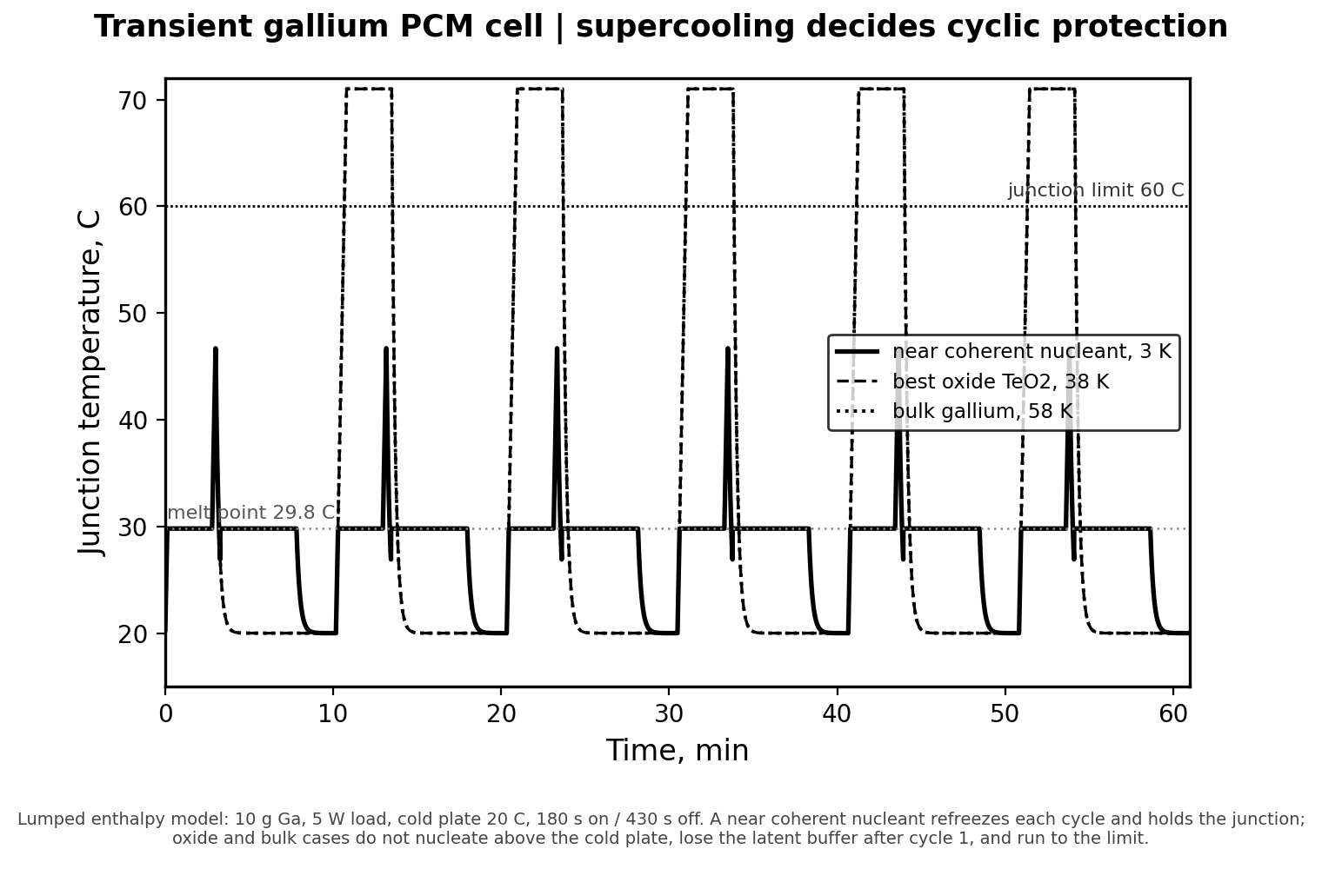
Fig. 4. Junction temperature of a gallium PCM cell over six load cycles. A near coherent nucleant (solid) refreezes each cycle and holds the junction near the melt point; the best oxide and bulk gallium (dashed and dotted) do not nucleate above the cold plate, lose the latent buffer after the first cycle, and run to the junction limit. Lumped model: ten gram buffer, five watt load, cold plate at 20 C.

3.8 Limitations
Several boundaries frame the result. The validation rests on twelve measured phases from two studies, enough for a strong rank correlation but not for a tight quantitative law. The map from potency to undercooling is a calibrated surrogate rather than a measured contact angle, and a slab level wetting calculation for HfN and ScN would put the two leading predictions on firmer ground. The stability gate uses bulk Ellingham free energies; for sub micron particles, surface energy and passivation can shift the balance the bulk numbers imply. The alloy result of Section 3.5 is a forward prediction. The device payoff of Sections 3.6 and 3.7 rests on literature values and a lumped, isothermal cell model rather than a measurement on the present candidates; a large pack would need a spatially resolved model, and the recovered fraction, the protection time, and the property penalties should be confirmed on a built cell.

4. Conclusions
Choosing a nucleant for gallium works better when lattice match and melt stability are weighed together. Run through the Odinzen engine, classical heterogeneous nucleation reproduces the homogeneous supercooling of pure gallium and the interfacial energy the field uses, recovers the measured order of the oxide nucleants, and confirms TeO2 as the best of them, acting through reduction products that are themselves near coherent to alpha-Ga. A screen across thirty seven oxides, carbides, nitrides, and borides isolates a stable, near coherent family led by HfN and ScN, in a class whose carbide and nitride members already cut gallium supercooling below 10 and 20 C. HfN and ScN are the near coherent agents still untested, and either one can be confirmed or ruled out by a single calorimetry run. A lumped cell model carries the same residual supercooling into device protection time, where clearing the thermal margin between the melt point and the cold plate separates a buffer that holds from one that overheats.

CRediT authorship contribution statement
Michael E. Bustamante: Conceptualization, Methodology, Software, Formal analysis, Investigation, Visualization, Writing original draft, Writing review and editing. Bustamante is the sole author.
Gabriel Bustamante: Software, Methodology, Writing – review & editing.

Declaration of competing interest
The author declares that he has no known competing financial interests or personal relationships that could have appeared to influence the work reported in this paper.

Acknowledgements
This research received no specific grant from any funding agency in the public, commercial, or not for profit sectors.

Data availability
The nucleant screening dataset (Table S2) and validation statistics (Table S3) are provided as CSV files in the Supplementary Information. The Python script that produced Fig. 4 (pcm_cell_model.py) is included in the same archive. The complete data and code archive will be deposited at Zenodo (DOI to be assigned upon acceptance); all files are available from the corresponding author on request.

Declaration of generative AI and AI-assisted technologies in the writing process
During the preparation of this work the author used Anthropic Claude, a large language model based assistant, to draft and edit manuscript prose and to organise the presentation of the results. The thermodynamic and nucleation calculations, the underlying data, and the scientific conclusions were produced and checked independently of that tool. After using it, the author reviewed and edited all content and takes full responsibility for the content of the publication.

References
[1] C. Zhang, L. Li, X. Yang, J. Shi, L. Gui, J. Liu, Study on the nucleating agents for gallium to reduce its supercooling, Int. J. Heat Mass Transfer 148 (2020) 119055. https://doi.org/10.1016/j.ijheatmasstransfer.2019.119055
[2] H. Niu, L. Bonati, P.M. Piaggi, M. Parrinello, Ab initio phase diagram and nucleation of gallium, Nat. Commun. 11 (2020) 2654. https://doi.org/10.1038/s41467-020-16372-9
[3] J. Majzlan, S. Notz, P. Haase, E.I. Kamitsos, N.S. Tagiara, E. Dachs, Thermodynamic properties of tellurite, paratellurite, TeO2 glass and Te(IV) phases, Geochemistry 82 (2022) 125915. https://doi.org/10.1016/j.chemer.2022.125915
[4] A. Koh, W. Hwang, P.Y. Zavalij, S. Chun, G. Slipher, R. Mrozek, Solidification and melting phase change behavior of eutectic gallium indium tin, Materialia 8 (2019) 100512. https://doi.org/10.1016/j.mtla.2019.100512
[5] D. Turnbull, Formation of crystal nuclei in liquid metals, J. Appl. Phys. 21 (1950) 1022. https://doi.org/10.1063/1.1699435
[6] B.L. Bramfitt, The effect of carbide and nitride additions on the heterogeneous nucleation of liquid iron, Metall. Trans. 1 (1970) 1987. https://doi.org/10.1007/bf02642799
[7] M. Telkes, Nucleation of supersaturated inorganic salt solutions, Ind. Eng. Chem. 44 (1952) 1308. https://doi.org/10.1021/ie50510a036
[8] M. Zinkevich, F. Aldinger, Thermodynamic assessment of the gallium-oxygen system, J. Am. Ceram. Soc. 87 (2004) 683. https://doi.org/10.1111/j.1551-2916.2004.00683.x
[9] S. Gosse, Tellurium oxides: thermodynamics and phase relations in the Te-O system, J. Phase Equilibria Diffus. 46 (2025) 20-30. https://doi.org/10.1007/s11669-025-01175-6
[10] I.D. Joshipura, C.K. Nguyen, C. Quinn, J. Yang, D.H. Morales, E. Santiso, T. Daeneke, V.K. Truong, M.D. Dickey, An atomically smooth container: can the native oxide promote supercooling of liquid gallium?, iScience 26 (2023) 106493. https://doi.org/10.1016/j.isci.2023.106493
[11] S. Chakravarty, D.J. Sharar, P.J. Shamberger, Heterogeneous nucleation of gallium with lattice-matched cubic carbide and nitride phases, J. Appl. Phys. 130 (2021) 125107. https://doi.org/10.1063/5.0060207
[12] S. Ki, S. Shin, S. Cho, S. Bang, D. Choi, Y. Nam, Sustainable thermal regulation of electronics via mitigated supercooling of porous gallium-based phase change materials, Adv. Sci. 11 (2024) 2310185. https://doi.org/10.1002/advs.202310185
[13] Y. Cao, J. Park, G. Dodbiba, T. Ono, C. Tokoro, T. Fujita, Keeping gallium metal to liquid state under the freezing point by using silica nanoparticles, Appl. Phys. Lett. 99 (2011) 143120. https://doi.org/10.1063/1.3645596

